**AQLI Data Test Answers**

1. **Basic Wrangling Tasks and Questions**

1.1 How many GADM2 regions are present in India?

GADM2 regions are present in India: **668**

**1.2 Calculate population-weighted pollution average of all years at country (GADM0) level**

**Approach used:**

This approach ensures that areas with higher populations contribute more to the national pollution average, rather than treating all regions equally.

* Save the country level file as a CSV



[**View Github Link**](https://github.com/Puru-Gupta/AQLI-/blob/main/Output/1.2%20population%20weighted%20pollution%20average%20of%20all%20years.csv)

* What are the 10 most polluted countries in 2021?

Bangladesh, India, Nepal, Pakistan, Mongolia, Myanmar,

Democratic Republic of Congo, Republic of the Congo, Rwanda, Burundi

* 1. **Most Polluted GADM2 Region in the World**
* 1998, 2005, 2021

|  |  |  |  |  |
| --- | --- | --- | --- | --- |
| **Country** | **State** | **City** | **Year** | **Pollution** |
| India | Uttar Pradesh | Unnao | 1998 | 78.6 |
| India | NCT of Delhi | NCT of Delhi | 2005 | 98.8 |
| India | NCT of Delhi | NCT of Delhi | 2021 | 127.0 |

* 1. **Population Weighted Pollution Trendline for Uttar Pradesh (1998-2021)**

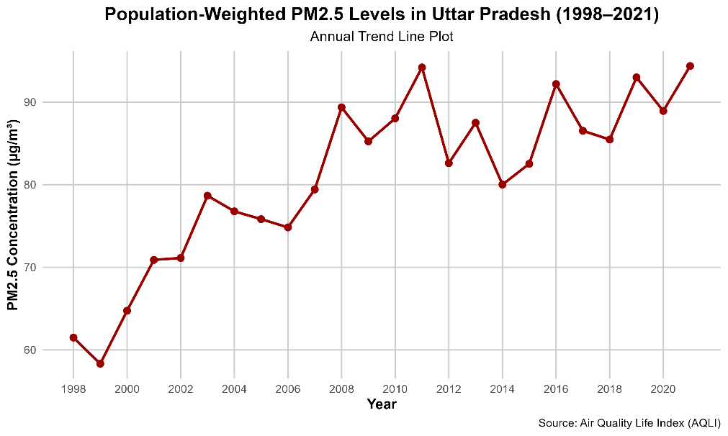

[**View Github Link**](https://github.com/Puru-Gupta/AQLI-/blob/main/Output/1.4_Population_Weighted_Pollution_Trend.png)

**2. Geospatial Tasks and Questions**

**2.1 Bar graph for the life years lost relative to the WHO guideline in the 10 most polluted countries in the world**

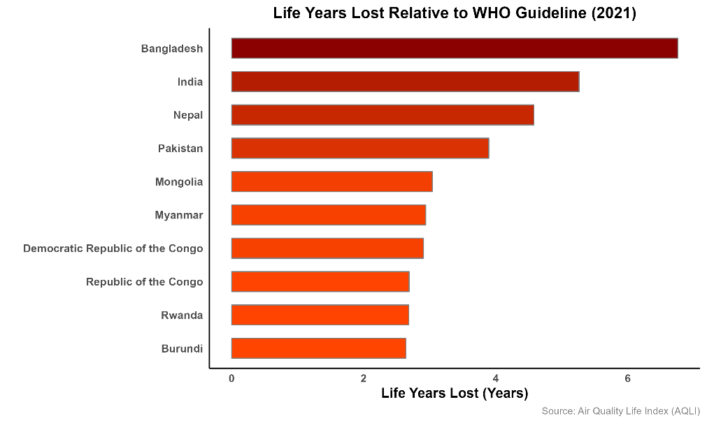

[**View Github Link**](https://github.com/Puru-Gupta/AQLI-/blob/main/Output/top_10_polluted_0level.png)

* Global country-level map highlighting the 10 most polluted countries in dark red.

[**View Github Link**](https://github.com/Puru-Gupta/AQLI-/blob/main/Output/name0_10%20most%20polluted%20countries%20.png)

**2.2 Potential Gain in Life Expectancy Map (Eastern vs. Western Europe)**

# Defined Eastern and Western Europe based on EuroVoc classification

# [Source](http://op.europa.eu/en/web/eu-vocabularies/concept-scheme/-/resource?uri=http://eurovoc.europa.eu/100277):

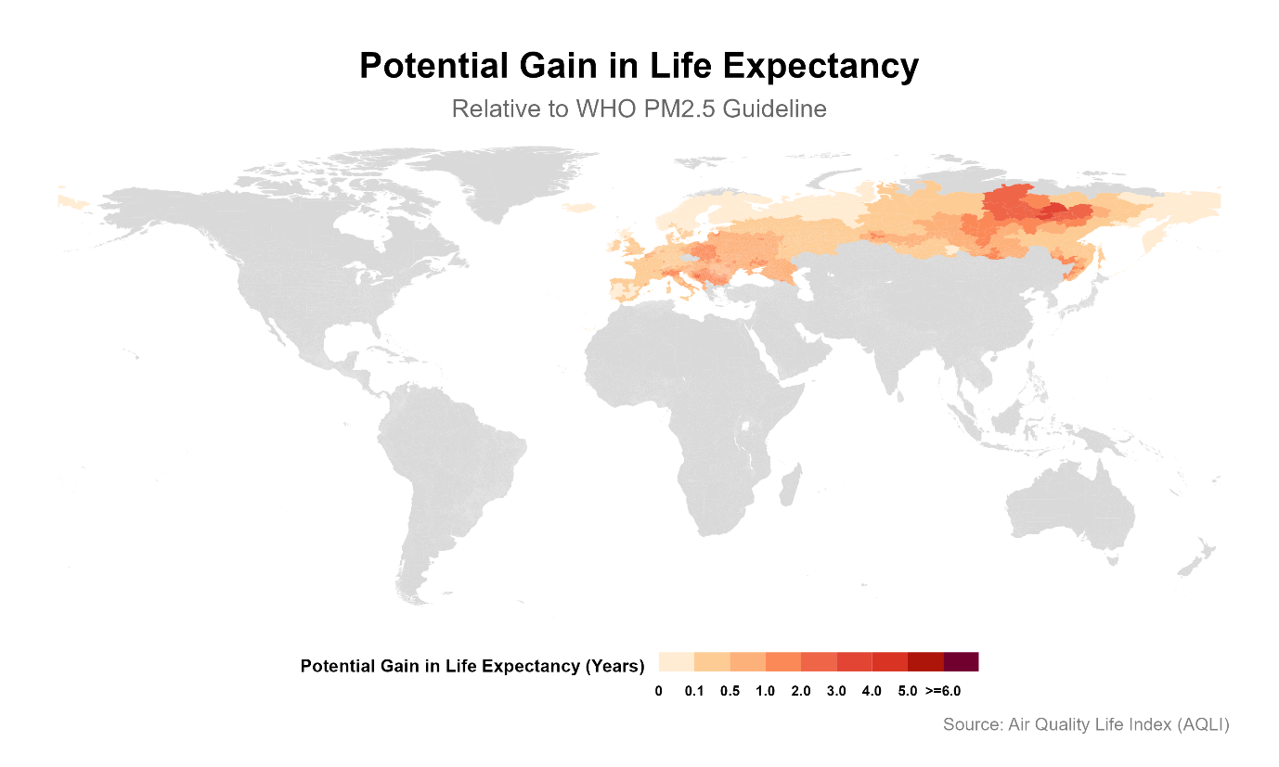

[**View Github Link**](https://github.com/Puru-Gupta/AQLI-/blob/main/Output/Europe_Potential_Gain_Life_Expectancy1.png)

[**View Google Drive Link (pdf)**](https://drive.google.com/file/d/1AX_PTSKBganZLdHOW7RbQaKo70KwjsfE/view?usp=drive_link)

**2.3 Static Global Pollution Map**

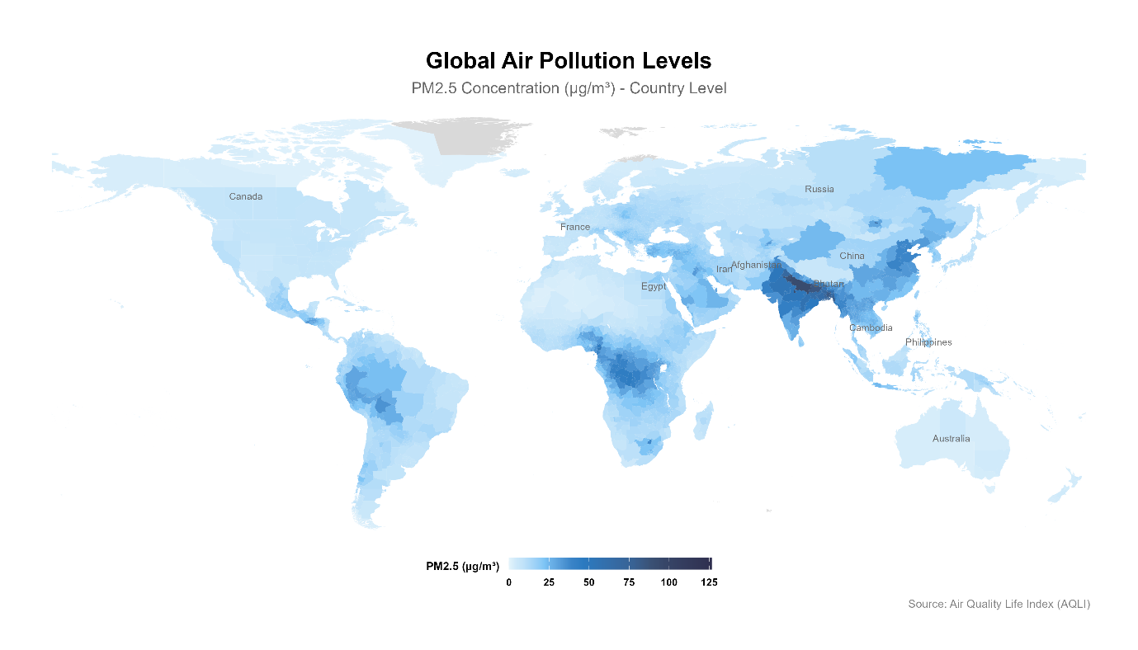

[**View Github Link (png)**](https://github.com/Puru-Gupta/AQLI-/blob/main/Output/Country_Level_Air_Pollution.png)

[**Google Drive Link (SVG)**](https://drive.google.com/file/d/1f3C1EhZ3nDkZgOSlBQAAbnj78OqLQbIv/view?usp=drive_link)

**3. GitHub Submission**

[**Github Link**](https://github.com/Puru-Gupta/AQLI-/blob/main/Output/1.2%20population%20weighted%20pollution%20average%20of%20all%20years.csv)

**4. Verbal Reasoning and Writing**

**Key Takeaways from the AQLI Annual Update 2024:**

1. The most polluted regions have air six times dirtier than the cleanest ones, reducing life expectancy by 2.7 years.
2. Policy ambitions vary; while some countries enforce strict air quality standards, others lack regulations altogether.
3. If all regions met their air quality standards, over 3 billion life-years would be gained globally.